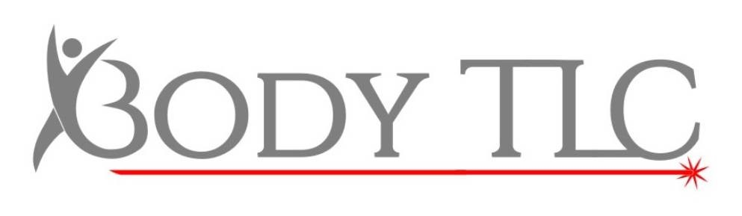

Aftercare for Veins & Skin Rejuvenation

- Avoid sun exposure and tanning creams for the entire duration of your course of treatments. Use SPF 30 or greater on the treatment area at all times
- The treatment area may be left open and uncovered.
- Do not scrub the area in the shower and keep the water temperature low for 24-48 hours.
- Negative reactions are very rare but if you feel sore take an over the counter pain or anti-inflammatory medication.
- To prevent infection if the skin is broken we recommend an antibiotic ointment such as Neosporin.
- Should the treatment area be itchy, a Hydrocortisone (Steroid) cream can be applied.
- Avoid excess sweating eg. Saunas, steam rooms or vigorous exercise for 24-48 hours.
- Keep the area well moisturised and keep yourself hydrated
- Avoid irritants and exfoliators for 1 week.
- Refrain from consuming alcohol for 3-7 days as it may dilate the blood vessels in the treatment area.
- We advise to refrain from smoking for a period of several weeks prior to and after the procedure as smoking constricts the capillaries and taxes the immune system which will slow healing and results.
- During Vein Removal, the area may bruise, blister or scab
- Avoid touching the area, do not pick at the flaky skin – it is essential that the area heals naturally. Bacteria on your fingers can lead to infection and infections lead to scars.

If you are in any doubt or have any concerns please call us on 01522 394618

