405 High Street, Lincoln LN5 7TE

01522 394618 www.BodyTLC.co.uk
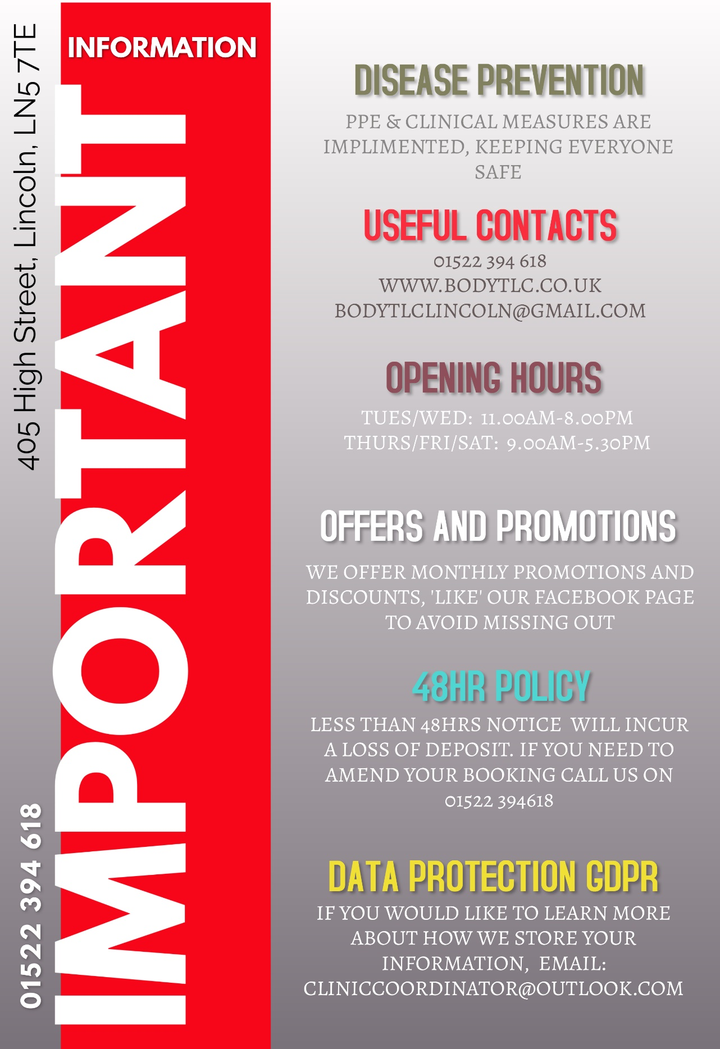

We appreciate that offering a wide range of services can seem overwhelming, we encourage you to learn about all we have on offer by perusing this book and visiting our website www.BodyTLC.co.uk
However, to help you jump straight to the section that interests you please use the index below
Index

LASER TREATMENTS: Tattoos / Hair / Veins / Fractional Laser Resurfacing / Fungal Nail / Femitone & Laser Teeth Whitening | Pages  5-10
MEDISPA SERVICES: Plasma Firboblast Treatment / iPRF / PRP, Hair Restoration & Wound Repair | Pages  10 -11
INJECTABLE AESTHETICS: Dermal Fillers/ No Needle Filler / Skin Boosters, Botox: Wrinkles, Sweating, Teeth Grinding, Migraine, Gummy Smile & Baby Botox | Pages  12-13
SCALP MICROPIGMENTATION, SEMI PERMANENT MAKE UP & MICROBLADING: Eyeliner, Lips, Brows and Eyeshadow, Microblading / Hair Microblading & Scalp Micropigmentation | Pages  14 - 15
EXTRACTIONS & REMOVALS: Small Cysts, Acne, Milia, Pigmentation, Warts, Verruca, Cherry Angiomas, Skin Tags & Moles | Pages  16 - 17
WEIGHT & SHAPE: Liposonics / Fat Dissolving Injections / Vela / Radio Frequency / Ultrasonic Cavitation / Cellulite Buster / Lymphatic Drainage/ The Genie & Body Wraps | Pages  18 - 24
BEAUTY AND MASSAGE: Massage / Waxing / Tanning / Tinting / Manicures / Pedicures / Nail Repair & Ear Piercing | Pages  24 - 28
FACIALS: All our facials now in one convenient place alongside our facial scanning options | Pages  28 - 31
HEALTH & DETOX: Food Intolerance & Medical Testing / Aqua Detox / B12 Injections / Hopi Ear Candles / Callus Peel / Life Coaching | Pages  32 - 33
PACKAGE TREATMENTS: Mum to Be / Student Pamper Package / Bride & Groom Offers / Couples Days & Membership Deals | Pages  34- 37

BODY TLC PRICE LIST

Patch Tests & Consultations
For a high number of our services, a patch test is required. This is typically completed during a consultation so that suitability can be ascertained, your medical history can be checked for contraindications, and the process can be discussed alongside aftercare and possible side effects.
Our therapists may refuse service if they deem the treatment to pose risk without a prior patch test.
Consultations are offered FREE* and with no obligation to book ANY of our treatments.
Consultation FREE* Laser Patch Test £10 Beauty Patch Test £5
Patch Test price redeemable off your first paid treatment.
*Refundable booking deposit of £5 required
Deposits
Due to the clinical cost of missed appointments, we ask for a deposit to secure your booking. For our free consultations this is a £5 deposit. When you attend your appointment, the deposit can be used against the cost of your patch test or future treatment. If you do not wish to receive a patch test or book at that point, then the £5 deposit is refunded to you in the same manner in which you paid.
All deposits are non-refundable should you fail to attend your appointment / fail to provide 48hrs notice to alter your appointment. If you provide more than 48hrs notice the deposit can be moved seamlessly to your rearranged appointment or refunded in full, should you wish to postpone or cancel your appointment.
In general, we ask for the following deposits against the treatment booking – the deposit secures your booking date, when you attend the deposit is then deducted from your total treatment costs.

Small Appointments £5 Medium Appointments £15 Large Appointments £30
Laser Treatments

Tattoo Removal Services
You will require a consultation and patch test prior to your treatment. Prices are a guide; your therapist will consider how much skin within the measured area contains ink and how much is clear. A quote will be given at your consultation.

Size | Classification | Q Switch Laser | Picosure  Laser | Saline  Removal
A ring Finger Tattoo | Class One | £24 | £36 | £20
Example: 5cm x 5cm | Class Two | £36 | £54 | £30
Example: 7cm x 7cm | Class Three | £48 | £72 | £40
Example: 9cm x 9cm | Class Four | £60 | £90 | £50
Example: 11cm x 11cm | Class Five | £72 | £108 | £60
Example: 13cm x 13cm | Class Six | £84 | £126 | £70
Example: 15cm x 15cm | Class Seven | £98 | £144 | £80
Example: 17cm x 17cm | Class Eight | £108 | £162 | NA
Example: 19cm x 19cm | Class Nine | £132 | £198 | NA
Example: 21cm x 21cm | Class Ten | £156 | £234 | NA
Example: 23cm x 23cm | Class Eleven | £180 | £270 | NA
Example: 25cm x 25cm | Class Twelve | £204 | £306 | NA

Pay up for 5 sessions up front – get a free Aloe Vera Gel and save 10% on the cost of your treatment!
Pay for two or more tattoos to be treated at the same time – save 10%
Saline Solution is an option for certain pigment colours / locations of tattoo – it is not advised in general for most tattoo clients. Your therapist can advise you on the best option for your specific tattoo.
Diode Laser Hair Removal

Permanent Laser Hair Removal. Prices listed are per area, and per course of 6. Buying a course of treatments will save you approximately 20%. Other areas are available on request – Please get in touch for a bespoke package.
Ladies  Area | Per  Treatment | Course  of 6 | Area | Per  Treatment | Course  of 6
Chin | £60 | £288 | Upper Lip | £48 | £230.50
Underarms | £66 | £317 | Neck (front) | £60 | £288
Stomach Line (teddy) | £60 | £288 | Nipples | £60 | £288
Lower Back | £84 | £403 | Abdomen (from) | £72 | £345.50
Bikini (std) | £72 | £345.50 | Upper Arms | £84 | £403
Bikini (extended) | £108 | £518.50 | Forearms | £84 | £403
Bikini (all hair) | £132 | £633.50 | Full Arms | £144 | £691
Buttocks | £84 | £403 | Full Legs | £299 | £1434
Thighs | £180 | £864 | Lower Legs + Knees | £162 | £777.50

COMBINATION OFFERS | Per Treatment | Course of 6
Bikini (std) + Underarms | £132 | £633.50
Bikini (extended) + Underarms | £162 | £777.50
Bikini (all hair) + Underarm | £186 | £893
Ext Bikini, Underarms, Lower Legs + Knees | £300 | £1700
All Bikini, Underarms + Full Legs | £450 | £2500
Lip, Chin + Cheeks | £108 | £518.50
Upper Lip + Chin | £84 | £403

Gentlemen | X 1 | X 6 | Area | X 1 | X 6
Male Beard | £144 | £691 | Underarms | £66 | £317
Beard + Neck | £180 | £864 | Forearms | £90 | £432
Chest + Abdomen | £216 | £1037 | Full Arms | £156 | £749
Full Chest | £120 | £576 | Upper Arms | £90 | £432
Half Back | £120 | £576 | Male Groin (std) | £72 | £345.50
Full Back | £216 | £1037 | Male Groin (ext) | £108 | £518.50
Full Legs | £299 | £1434 | Male Groin (comp) | £144 | £690
Hands or Feet | £84 | £403 | Other Areas | POA | POA
Laser Vein Removal
Body TLC’s Laser Vein Removal can restore your complexion and reduce those unsightly broken veins. With the safe elimination of coloured veins, you gain the freedom to bare your skin. You will require a consultation to ascertain your suitability. This treatment is not suitable for varicose veins, dark or recently tanned skin, or those suffering from thin skin or on certain medications.

Treatment  Area Size | Per  Treatment | Course of 3  (Saving 20%)
Extra Minor Area from | £48 | £115
Minor Area from | £108 | £259
Intermediate Area from | £168 | £403
Moderate Area from | £228 | £547
Major Area from | £294 | £705.50

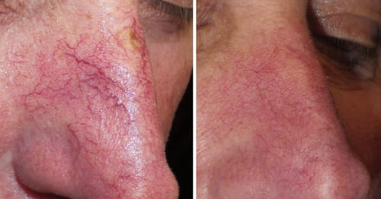
Some Veins are suitable for treatment with our Diathermy Service. See pages 15 – 17

Above. Before and after healing of nasal broken capillaries treated with Diathermy. Below. Before and after three sessions of Laser Vein Removal on the thigh area.
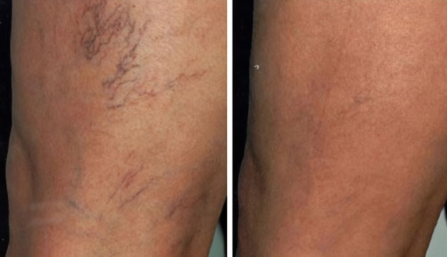

CO2 Fractional Laser Treatments for Anti-Aging, Skin Conditions & Skin Tightening
Fractional Laser Treatments offer amazing results, tightening skin, reducing scars, improving signs of aging, and offering skin levelling in pigmentation, tone, evenness, visual veins, and colour. Downtime is approximately 4 – 7 days depending on severity of the skin tissue being treated.

Fractional Laser Services are priced per area, per treatment and in courses of 3 (saving 10%). You will need a consultation prior to treatment, your therapist will be able to give you an accurate quote at your consultation.

We may be able to offer discounts where more than one area is treated concurrently.

Treatment Area  (Example size) | Per Treatment | Course of  Three
Small Area (forehead or small patch) | £299 | £807
Medium Area (full face or both hands) | £359 | £969
Large Area (full face +neck or neck décolletage) | £459 | £1239
XL Area (stomach or full face +neck +décolleté) | £499 | £1347
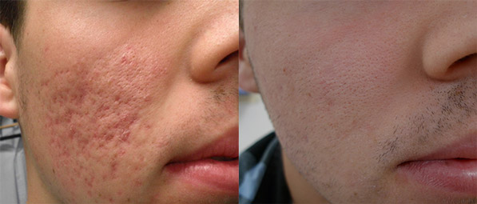

Shown here
improving scars
from prior acne.

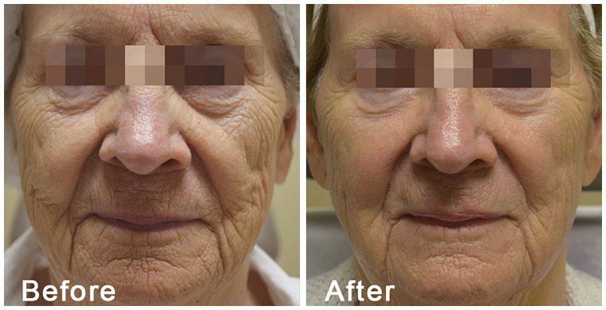
Both images
show before and
after 1 single
Fractional Laser
Treatment.
Laser Fungal Nail Treatment
Fungal Nail Treatment – Kills the fungus that infects and spreads between nail beds. Usually only one to two treatment is all that is needed to cure the contagious spores, restoring beautiful fingers and toes once more. Extreme cases may require multiple sessions. Please visit our website for more information.

Treatment | 1st Treatment | 2nd Treatment | 3rd Treatment
Individual Nail | £119 | £83 | £59
One Foot OR Hand | £299 | £239 | £150
Both Feet OR Hands | £419 | £298 | £210
Follow-Up Deep File and Scrape  (incl. in laser sessions & available as a standalone service) | £30-40
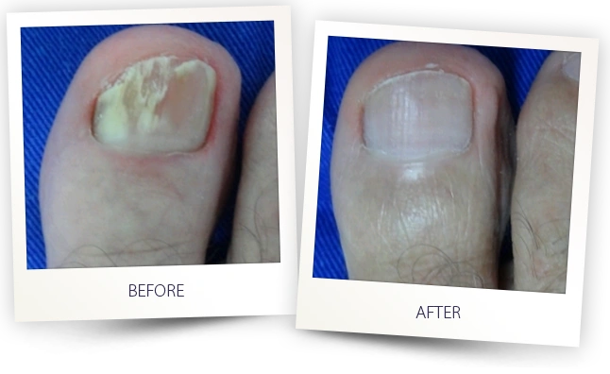

Femitone
Femitone is the non-surgical Laser alternative to
intimate vaginal surgery. Stimulating collagen
formation in a non-painful manner. This treatment
is also useful to prevent the symptoms of incontinence.
A consultation prior to treatment is required to check
suitability. Absolute discretion is given as standard.

£400 Per Treatment
£1000 Course of 3
£200 Annual/ Bi-Annual Booster

Laser Teeth Whitening
Laser Teeth Whitening painlessly lifts stains from the teeth in one session.
£69 for Standard Lift £99 for Mega Lift

Medispa Services

Plasma Firbroblast Treatment
This innovative technology utilises plasma to stimulate instant contraction and tightening of skin fibres. This technology does not use a scalpel or laser to remove excess skin, thereby avoiding all risks inherent to the traditional methods. Results can be seen immediately, though 14 day downtime post treatment is expected.

Treatment Area | 1st Treatment | 2nd Treatment | Following Treatments
Upper Eye Lift | £360 | £240 | £180
Lower Eye Bag | £360 | £240 | £180
Upper & Lower Eye | £570 | £420 | £330
Smokers Lines | £336 | £228 | £156
For blemish removal with Plasma please see page 16
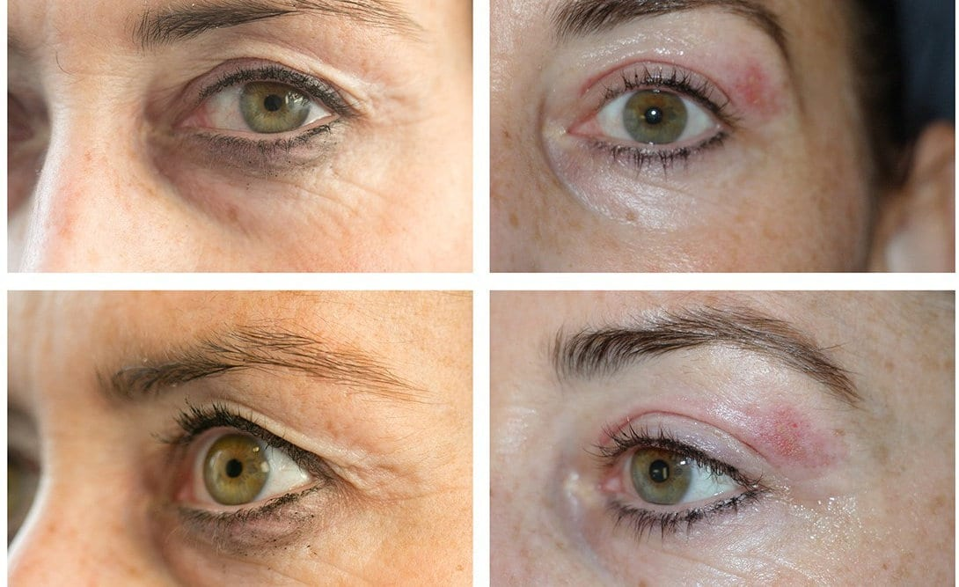

Platelet Rich Plasma & Stem Cell Platelet Rich Fibrin

You can learn so many interesting facts on this service via our website www.BodyTLC.co.uk/prp-prf

This treatment is completely homeopathic – meaning all natural, nothing but your own serum is returned to the skin. Your blood is drawn and spun in a centrifuge to separate your red blood cells from the powerful PRP or iPRF ready for redeployment back in your area of concern. Helping a vast range of ailments. Book a free consultation to learn more of how this can help you!

Concern | Size | PRP / for 3 | iPRF / for 3
Wound/Scar | Extra Large | £175 / £450 | £200 / £500
 | Large | £150 / £400 | £175 / £450
 | Medium | £125 / £300 | £150 / £400
 | Small | £100 / £250 | £125 / £300
Facial – Vampire | Full Face Treatment | £120 / £320 | £150 / £400
Facial - Dracula | Face, Neck & Decolletage | £240 / £695 | £300 / £800
Hair Restoration | 10-20ml (Small Sections) | £100 / £250 | £120 / £320
 | 20-30ml (Medium) | £120 / £320 | £150 / £400
 | 30-50ml (Large) | £240 / £695 | £300 / £800

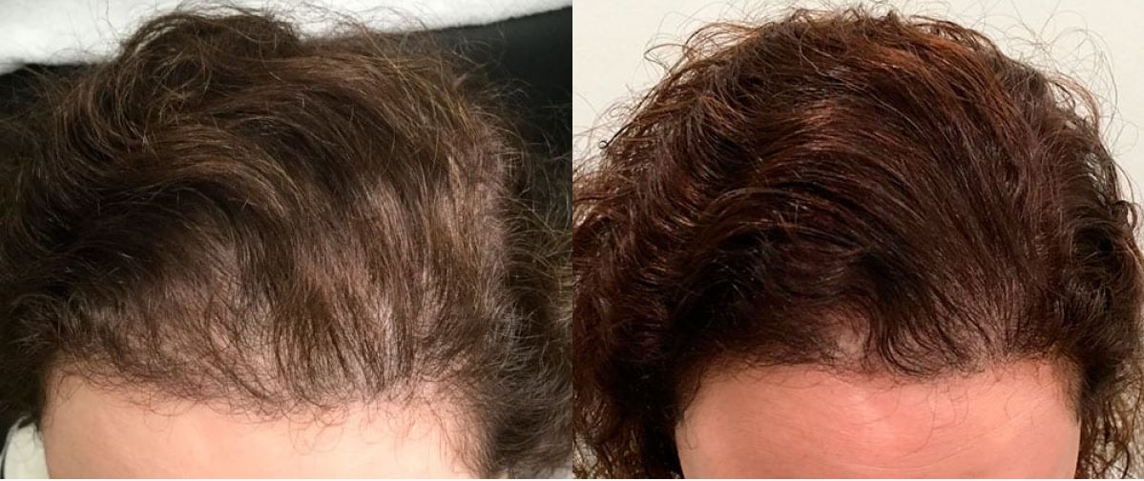

Interested in the hair restoration? We also offer Scalp Micro Pigmentation and Hair Microblading see pages 14 – 15
Aesthetic Injectables

At Body TLC we offer injectable Fat Dissolving Injections, please see page 19 and B12 Injections, See Pages 32-33

Dermal Filler Injectables

Made from Hyaluronic Acid, Dermal Fillers offer extreme hydration and volume for a wide range of uses, typically lips for contour or shape, cheeks, eyes, nose, and deep and shallow facial folds.

Amount of Dermal Filler | Filler that lasts 5-9m+ | Filler that lasts 9-12m+ | Filler lasting 12-18m+ | Specific Favourite Brands
0.5ml | £70 | £75 | £95 | On application
1ml | £120 | £130 | £180 | On application
1.5ml | £160 | £195 | £250 | On application
Additional ml’s each | 100 | £115 | £150 | On application
Nose Augmentation | £249 | £269 | £289 | On application
Tear Trough | / | / | / | £250
Chin & Jaw | £250 | £300 | £350 | On application
Hands | £300 | £350 | £400 | On application
Other Areas | On Quotation

Above. Shows minimal filler for a subtle natural look.
Also available on request: Hyglow No Needle Filler for those who want luxe lips but can’t bare the idea of needles! Book a free consultation for a quote.
Botox Injectables
A consultation is compulsory though may be possible via video call prior to your appointment. Botox is a prescription only item. Results last approximately 6-8 months. An optional 2 week top up is included free of charge.

Number of Areas | 1 Area | 2 Areas | 3 Areas
Wrinkle Reduction | £130  i.e. Crows Feet | £180  i.e. Crows and Frown Lines | £225  i.e. Crows, Frown and Forehead
Baby Botox | £70 | £140 | £210
Nefertiti Neck Lift | From £280 | Jaw Slimming | From £200
Botox for Sweating | From £350 | For Migraine | From £200
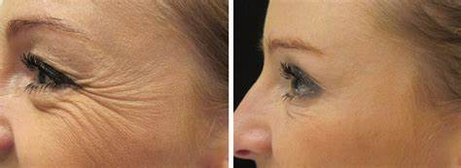

Skin Boosters & Profhilo
Other brands on request.
Product | Volume | Per session | Course of  (number) of sessions
Aquashine | 2ml | £120 | (x2) £220 (x3) £345
135 RTC Skin Booster | 3ml | £120 | (x3) £330 (x5) £520
Profhilo | 2ml  4ml | £250  £475 | (x2) £475 (x3) £599  (x2) £900 (x3) £1299
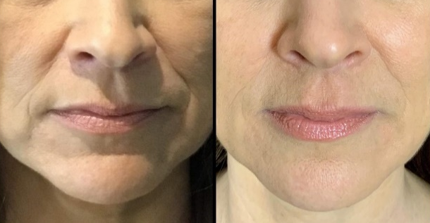

Microblading & Permanent Make-Up Treatments

Permanent Make Up

Our Semi-Permanent Make-Up is available in a range of styles to suit your personality and style. We offer a natural look, to mild make up or a fully made-up make-up look.
Choice of Brows, Eyeliner, Eyeshadow and Lip PMU.
We are able to offer Microblading, however find the results of PMU are more natural, long lasting and comfortable. For more information, please book a free consultation. See Hair Microblading on page 15.

Treatment | Cost | Treatment | Cost
Powder Brows | £299 | Eyeshadow Effect | £199
Hair Stroke Brows | £299 | Eyeshadow + Liner | £399
Ombre Brows | £320 | Lash Line Infill Only | £179
Aquarelle Lips | £299 | Under 5 Weeks Top Up | FREE
Lip Liner | £149 | Top Up with 70+% remaining pigment | Save 50%
Lip Liner & Blush | £249 | Top Up with 50-70% remaining | Save 40%
Delicate Eyeliner | £210 | Top Up with 30-50% remaining | Save 30%
Glam Eyeliner | £250 | Top Up with 20-30% remaining | Save 10%
Microblading | £210 | Microblading Top Up after 5 weeks | £110

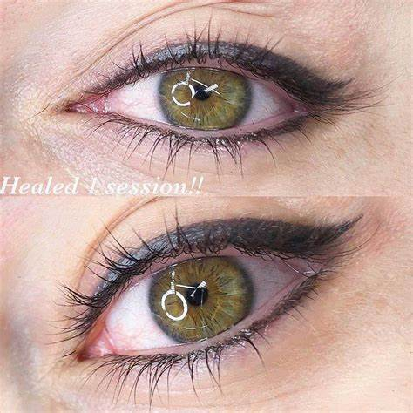

Scalp Micro Pigmentation – For Scarring
Small | £200 | Large 3 | £699
Medium | £500 | Ex Large 1 | £700
Large 1 | £600 | Ex Large 2 | £800
Large 2 | £650 | Ex Large 3 | £900

Scalp Micro Pigmentation – For Hair Line Alteration
Alteration 1 | £200 | Alteration 2 | £250 | Alteration 3 | £299

Scalp Micro Pigmentation – For Norwood Scale Hair Loss
Class Scale | Cost | Class Scale | Cost | Class Scale | Cost
3.1 | £300 | 4.5 | £749 | 6.3 | £1250
3.2 | £350 | 5,1 | £750 | 6.4 | £1399
3.3 | £375 | 5.2 | £800 | 6.5 | £1499
3.4 | £400 | 5.3 | £850 | 7.1 | £1500
3.5 | £449 | 5.4 | £900 | 7.2 | £1700
4,1 | £450 | 5.5 | £999 | 7.3 | £1950
4,2 | £525 | 6.1 | £1000 | 7.4 | £2250
4.3 | £600 | 6.2 | £1125 | 7.5 | £2500
4.4 | £675
The Norwood is a scale used to measure the degree of baldness on the scalp.
Hair Microblading
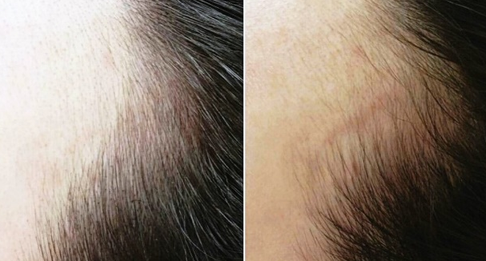
Hair Line Microblading can give the imitation of hairs that blend in fine edges.
Price on quotation.
from £200

Extractions and Removals

Blemish Removals

We advise booking a free consultation prior to booking treatment so that your therapist can access suitability and guide you to the best treatment option for you.

Concern | Treatment Via  Laser Treatment | Treatment Via  Diathermy | Treatment Via  Electrical Plasma
Freckle/s | Removal  From £48 | / | Removal  From £50
Pigmentation | Removal  From £48 | / | Removal  From £50
Sunspot/s | Removal  From £48 | / | Removal  From £50
Benign Mole/s | Removal  From £48 | Removal  From £70  Additionals for £24 each | Removal  From £83  Additionals for £34 each
Milia/s or  Cherry Angiomas | / | Removal  From £39 | Removal  From £46
Skin Tag/s | / | Removal  From £70  Additionals for £24 each | Removal  From £83  Additionals for £34 each
Verruca/s | / | Removal  From £70 | Removal  From £83
Wart | / | Removal  From £70  Additionals for £24 each | Removal  From £83  Additionals for £34 each
Sebaceous  Keratosis | / | / | Removal  From £48
Extractions & Removals

Each concern is unique and as such we may utilize different methods to deal with your concern – Diathermy, Laser, Extraction or Plasma are a few of the options available. The correct method will be discussed during a consultation.

- Cyst Removal
- Minor Lymphomas Based on consultation
- Infected or Blocked Follicle Prices from
- White Head Removal £39 - £149
- Black Head Removal
- Acne
- Cherry Angiomas

Price on application for large areas / multiple areas of concern
Additional Moles, Skin Tags & Milia may be treated for £24 Each if completed at same time. Additional Verruca completed at a reduced cost if treated at the same time.

Diathermy
Diathermy is used to treat raised Moles, Skin Tags, Milia, Thread Veins, and Verruca’s. The treatment involves the use of Radio Frequency through an extra fine gold needle and works to hyphenate the concern cleanly from the skin, sealing veins, forming a scab, once healed revealing new fresh smooth skin.

Please see the list on pages 16 -17 for our prices and option on blemish removal.

Diathermy Thread Vein Removal
Treatment Area Size | Per Treatment
Small | £44
Small to Medium | £71
Medium | £107
Medium to Large | £143
Large | £179

Weight & Shape Treatments

Please ask for a FREE consultation if you are unsure which treatment would best suit your needs, or read our 'Weight /Shape Treatments’ page on our website for more information on each treatment. A brief description of each treatment is below:

Interest free instalment plans are available

Liposonics
Our best fat loss treatment. Liposonics permanently destroys two layers of fat in almost any stubborn area! The fat does not re-deposit or come back, allowing permanent shape changing. Sold in ‘squares’ 6x6cm². 8 usually covers both flanks (love handles) 10 covers most full abdomens. Clinical studies proved over 91% lost between 1 and 4 inches and kept it off over a year (and counting).

‘One Treatment – One Hour – One Dress Size’*
£275 Per Treatment (8 squares) £25 Each Extra Square
*Once treatment has had time to show its effect

Vela lll Endermologie

Vela is best for cellulite and drainage. Using suction, rollers and Radio Frequency to lift, heat and sculpt simultaneously, melting fat and triggering new collagen production, whilst aiding excess fluid to drain away. This is the ideal treatment for smoothing areas of cellulite and slimming thighs. This can be also used on arms, the waist, the back, buttocks and legs.
Area | Per Session | Course of 3  Save 10% | Course of 6  Save 30%
1 Area | £45 | £120 | £189
2 Areas | £85 | £229 | £357
1 Area + Genie Cellulite Treatment Combination (Pg 23) | £80 | NA | £450

Fat Dissolving Injections

Ideal for those who can’t exercise but want to permanently reduce fat in any stubborn pocket of unwanted fat – including the dreaded double chin!
Area | Product:  Aqualyx | Product:  DesoBody | Product:  Cincelar+ | Product:  LipoLab  (for cellulite)
Chin  1st Vial | £180 | £180 | £225 | /
Chin Additional Vials offer | £90  Per vial | £90  Per vial | £112.50  Per vial | /
Body  1st Vial | £200 | £225 | £275 | £200
Body Additional Vials offer | £100  Per vial | £137.50  Per vial | £137.50  Per vial | £120  Per vial

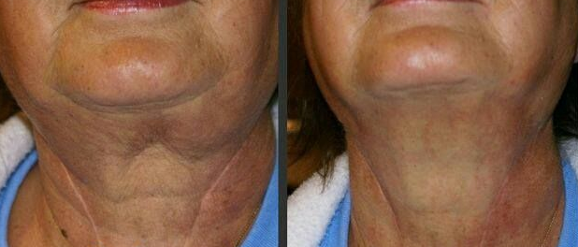

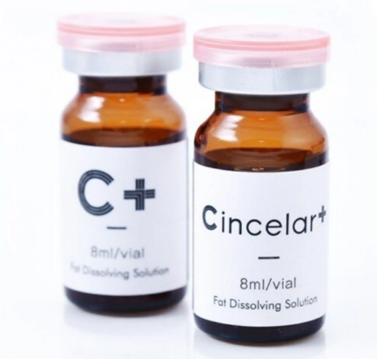
The main difference between the
brands on offer are the length of
time you can expect to be swollen in
the treatment area for, and if
anaesthetic is required.

Above photos show a lady before,
and 6 weeks after Cincelar+ Injections.
Area | £69 Per Treatment | £149 Course of 3
2 Areas | £129 Per treatment | £299 Course of 3
Ultrasonic Cavitation & Radio Frequency Weight and Shape

Ultrasonic Cavitation targets areas of stubborn fat with ultrasonic waves. The waves vibrate the water molecules deep in the fat layer, which in turn apply pressure to the surrounding fat cells causing them to implode, freeing up the energy into a burnable state. A fantastic option for those capable of mild exercise after treatment – burning off the released fat energy. To get even greater effect we recommend coupling this with lymphatic drainage. Ideal for customers who have stubborn weight despite exercise.
As this treatment utilises the body’s store of water to apply pressure to the fat cells, it is recommended to drink 2-3 litres of water each day in the week prior to treatment.

Radio Frequency Weight and Shape is ideal for targeting stubborn areas of hard fat, although it works on all types of fat. Great for any area of the body. Deep dermal heating shrinks aged collagen fibres and reduces fat cells. This results in firmer skin that improves as new collagen is produced and size is reduced.

Often your therapist may suggest a combination of part Ultrasonic Cavitation to prepare the cells perfectly for Radio Frequency to better reduce the area size. Your therapist can advise on this at consultation.

£50 Per Treatment £135 Course of 3

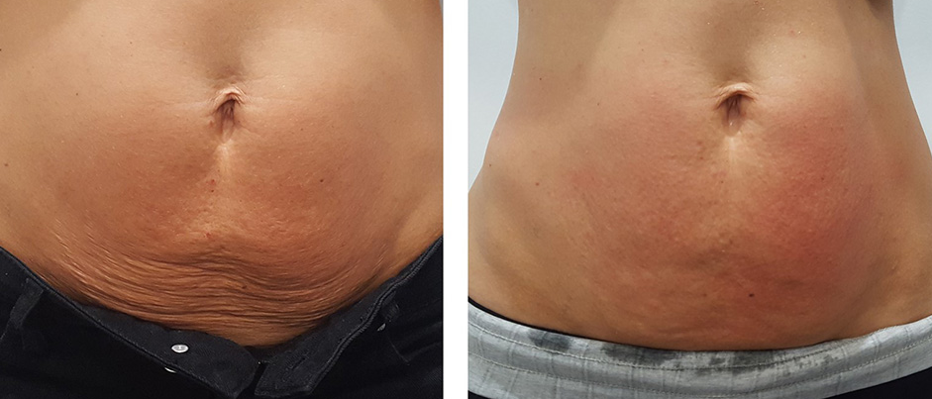

Shrinking Violet Body Wrap

The Shrinking Violet Body Wrap chemically alters the fat cells in the treatment area to aid destruction. The results are immediate and will increase over the following 72 hours. Shrinking violet is non-invasive and pain free!
Results last up to 30 days but increase with a course of treatment.
You are welcome to bring a bikini or swimming trunks, alternatively we have disposable items in clinic which you would be welcome to use during your wrap.
Treatment | Per Treatment | Course of 3 | Course of 6
Partial Body Wrap | £42 | £100 | £201
Full Body Wrap | £66 | £158 | £317
Extreme Boost Add On (1 Area) | £14 | - | -
Extreme Boost Add On (2 Areas) | £24 | - | -

COMBINATION OFFERS | Per Treatment | Course of 3
Partial Body Wrap & 2 Vials of Aqualyx / Desobody Fat Dissolving | £305 | £899
Partial Body Wrap & 2 Vials of Cincelar+ Fat Dissolving | £370 | £999

Hot Oil Envelopment Wrap

A wonderfully indulgent wrap incorporating a full body salt scrub to buff away dead cells and invigorate the skin, to better increase the absorption of our luxury hot oils. Once applied you are enveloped in a protective sheet and can unwind in a heated sauna blanket, where you may opt for a hot oil hair and scalp treatment. This addition is wonderful for adding shine and condition to your hair * You will leave with oil residue in your hair if you opt to enjoy the complimentary hair and scalp treatment.

Full Body Wrap £49

Cellulite Buster

This package is designed to directly address the much-hated cellulite we typically find on the buttock and thighs. Through experience we have found the best method is to approach this from all sides.

At your appointment we will help you understand the cause of cellulite and ways we can tackle this with homecare, alongside the following discounted package, including:

1 x LipoLab Cellulite Injectable - to target specific zones of textural fatty deposits.
1 x Genie Slimtone treatment - for cellulite on the thighs and buttocks
(Electrical stimulation to work the muscle to smooth cellulite above).
1 x Vela Endermologie treatment - to sculpt and smooth the deep mid layers and surface with the power of radio frequency.

Offer Price: £269
When these services are combined and received on the same day.

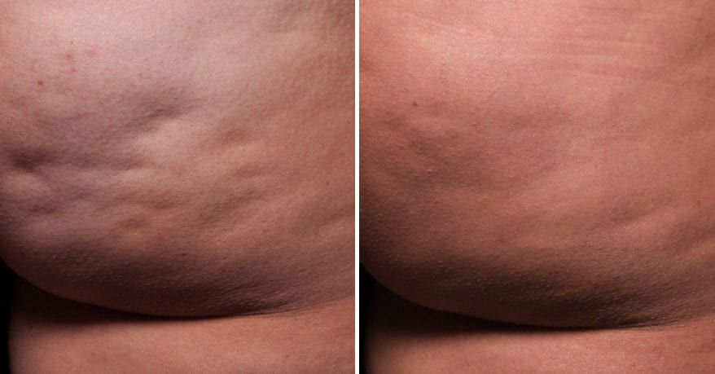

The Genie

Using the Genie we can address various concerns. The Genie uses electrical waves to stimulate the body’s natural drainage system, perfect for cellulite, redistributing liquid to achieve an even figure and improve circulatory problems.
The Genie can also stimulate a wide range of cells that may help tighten lax skin, and soften stretch marks and wrinkles, toning muscles and firming the treatment area.
Genie Non-Surgical Face Lift - 1000 x stronger than CACI. Taking only 10 minutes to effectively get your muscles into 'body building mode' lasting 24 hours post treatment. The Genie Take Ten firms the skin, gives an instant lift and redefines the facial contours.
The Genie uses electrical waves to stimulate the body’s natural drainage system, perfect for sinus fluid and puffy eyes, redistributing liquid to achieve an even figure and improve circulatory problems

Genie Stimulation Services | Per session | Course of 5 | Course of 10
Slim & Tone | £42 | NA | £336
Cellulite Treatment | £42 | NA | £336
Back Stress & Sciatica | £36 | £144 | NA
Loose Skin Treatment | £60 | NA | £480
Velvet Hands | £30 | NA | £240
Buttocks and Thigh Treatment | £54 | NA | £432
Satin Cleavage | £48 | NA | £384
Non-Surgical Face Lift | £34 | NA | £304
Non-Surgical Face Lift + Micro Tech | £60 | NA | £450
Eyes Like Diamonds | £30 | NA | £240
Lip Smoothing (corner lifting) | £30 | NA | £240
Lymphatic Drainage Face + Neck | £22 | £88 | NA
Lymphatic Face, Neck +Decolletage | £30 | £120 | NA
Sinus Drainage | £22 | £88 | NA
Lymphatic Body Drainage | £36 | £144 | NA
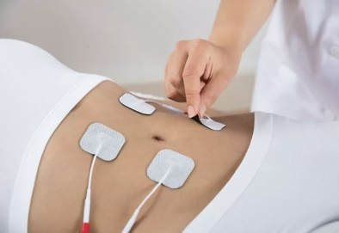
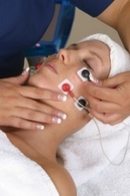

Traditional Beauty & Massage Treatments

Manicures & Pedicures

Treatment | Cost | Treatment | Cost
Standard Polish or No Polish
File, Tidy & Polish  *Fingers or Toes | £17 | Luxury Manicure or Pedicure – Std OPI or No Polish | £24
‘Man’ icure / Mans basic Pedicure  File, Shape & Cuticle Tidy (no polish) |  | £15
Gel Polish
Gel File & Polish - Manicure | £21 | Gel File & Polish - Pedicure | £21
Luxury Gel - Manicure | £33 | Luxury Gel - Pedicure | £33
Gel Removal & Tidy | £8 | Gel Removal Prior to New Nails in Clinic | £6

Nair Repair

IBX Nail Repair | Cost
1st Session 45 min | £33
Follow on Session 30 min | £23
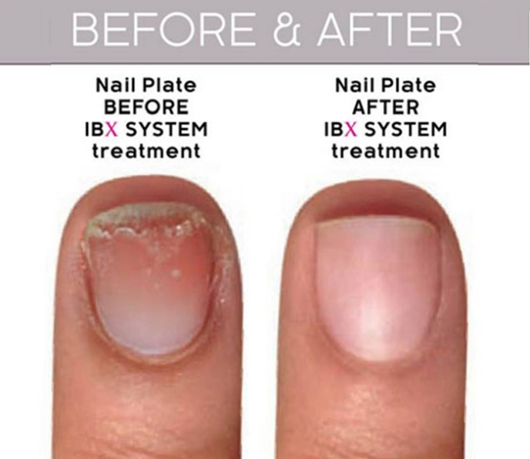

Eyebrows and Eyelash Tint and Shape

Treatment Area | Cost | Treatment Area |  | Cost
Eyebrow Tint | £11 | Eyebrow Shape Hot Wax |  | £11
Eyelash Tint | £11 | Eyebrow Shape Silk Wax |  | £10
Eyebrow & Eyelash Tint | £20 | Eyebrow Shape & Eyelash Tint |  | £20
Eyebrow Tint & Shape | £20 | Eyebrow Shape & Lash + Brow Tint |  | £32
Treatment |  | Cost per Treatment | Course of 3
Lash Lift & Tint |  | £44 | £107
Lash Lift, Without Tint |  | £38 | £92

Lash Lift & Tint Before and After - Results last up to 8 weeks.

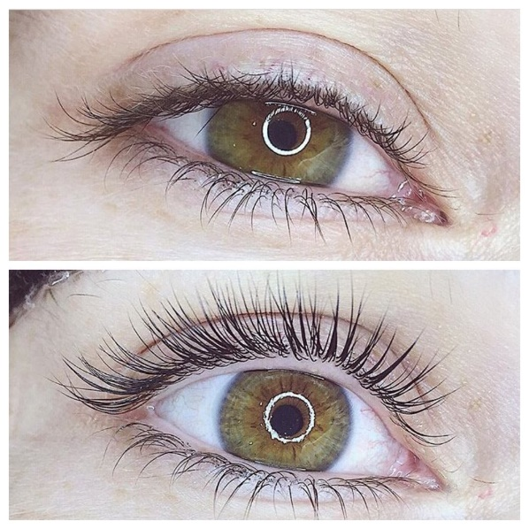
PMU Eyeliner wet line infills can also make your lashes look thicker & darker
See page 14.
Waxing
Ladies | Silk Wax (With Strips) | Hot Wax
Eyebrow | £10 | £11 / (x3) £26
Inner Nose |  | £9.50
Upper Lip | £8 | £11
Chin or Neck | £8 – 11.50 | £11 - 13
Lip & Chin |  | £15
Chin & Neck | £12.50 | £15.50
Extended Face | £15 | £18
Full Face | £23.50 | £27
Underarms | £11.50 | £14
Forearms | £16 | £20
Full Arms | £25 | £30
Standard Bikini | £14 | £18
Brazilian Bikini | £23.50 | £27
Playboy Bikini | £29 | £33.50
Hollywood Bikini | £29.50 | £42
Half Leg | £21
¾ Leg | £26
Full Leg | £30
Gentlemen | Cost - Silk Wax (With Strips) | Hot Wax
Ext Face | £17.50 | £20.50
Shoulders | £15.50
Full Back | £23.50
Upper Chest | £20.50
Abdomen | £17.50
Manzillian |  | £44
Columbian |  | £48
BSC | - | £78
Buttocks | £15 | £18
Offers | Combo Wax | Cost
Full Leg & Hollywood | Silk & Hot Wax Combo | £66
Beach Beauty | Silk & Hot Wax Combo  Upper Lip, Eyebrow, Underarm, Full Leg and Playboy or Hollywood Bikini | £90
Fun in the Sun – (2 options) | Silk & Hot Wax Combo  1/Upper Lip, Eyebrow, Underarm, Std Bikini+ ¾ leg. Or 2/ Full Back, Upper Chest + Abdomen | £59
Professional Spray Tan

Here at Body TLC we use Professional Spray Tan products to give you an instant sun-kissed colour which develops into a flawless tan by working with the melanin in your skin and therefore preventing streaking.
We advise you prep ahead of treatment and wear dark clothes to your booking. No deodorant or jewellery, and where possible, avoid hot and sweaty days.

£26.50 Per Treatment

Massage

Treatment | Duration | Cost | Course of 3 or 6
Indian Head Massage | 25 Minutes | £24 | NA
Swedish Massage | 25 Minutes | £30 | £89 / £144
Swedish Massage | 55 Minutes | £44 | £106 / £211
Hot Stone Massage | 25 Minutes | £34 | NA
Hot Stones Massage | 55 Minutes | £60 | £177 / £288
Aqua Cushion Massage | 25 Minutes | £31 | NA
Aqua Cushion Massage | 55 Minutes | £55 | NA
Foot Massage | 25 Minutes | £30 | NA

Massage Offers | Duration | Cost
Swedish Massage & Express Facial | 75 Minutes | £66
Hot Stones Massage & Express Facial | 75 Minutes | £78
Foot Massage – Optional add on to services such as facials, teeth whitening or manicures or pedicures | 20 min | £10
Hand and Arm – Optional add on to other services like teeth whitening or body wraps, please ask if you’re unsure of suitability | 20 min | £10

Ear Piercing - All prices include the required number of studs.
Single Ear Piercing - £14 | Two Ear Piercings- £24 | Quad Lobe Piercing - £42
Aftercare lotion – FREE for under 10’s & £1 for those over
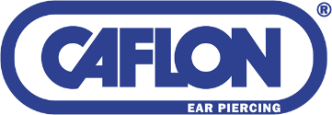

Caflon – The safest way to pierce ears

Skin Rejuvenation & Face Sculpting Treatments

Facial Scanning

Perfect pre & post treatment plans. To ensure the correct treatment path for your skins needs. We offer a mini scan which gives you the results of the scan and a printout, and a detailed scan which also gives you consultation time with a therapist to explain the findings and ascertain how we can best help you.
Our scan is detailed, offering a multi layered look at your skin above and below the surface. See how your skin compares with others of your age, see the sun damage hiding below the surface, alongside veins, pores, sensitivity, wrinkles and more.
Mini Facial Scan £10 Per Treatment Detailed Facial Scan £20 Per Treatment
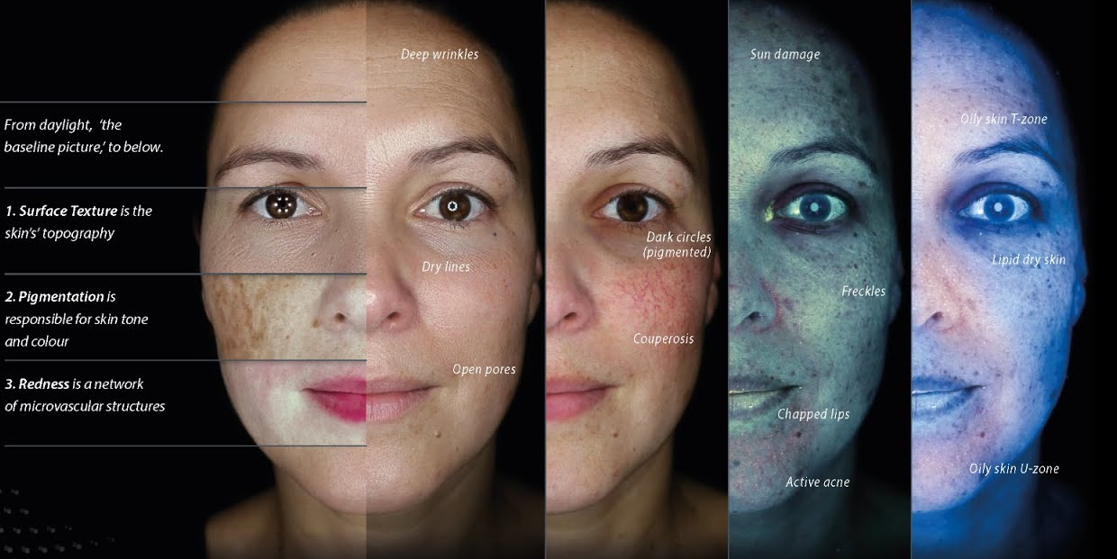

Facials

Treatment | Cost | What’s Included
Express | £23 | 20 Minutes - Perfect for newcomers to experience a facial and gather expert tips on cleansing & taking care of their skin.
Extraction | £15  £25  £35  £59 | 10 minutes: Professional extraction of black/white heads and suitable acne pustules/pimples  20 minute extraction  30 minute extraction  60 minutes for extreme extraction
Initial Prescription Facial | £69 | 90 Minutes - Our Initial Prescription Facial includes a Facial Scan so that we can select the products that will work best with your skin type and issue – Tailor made!
Prescription Facial | £59 | 60 Minutes - This option is for those who have already had the Initial Prescription Facial and who’s skin care range and issues we already understand.
Derma  -planing | £72 | Dermaplaning is designed to remove dead skin cells from the surface of the skin and is a great treatment for those who have previously suffered from acne, and subsequently have scarring in addition to treating the first signs of ageing: fine lines and wrinkles. Unlike other exfoliants, Dermaplaning has no risk of breaking capillaries in the skin and, as an added bonus, removes unwanted downy hairs from the face.
Derma  -planing  Deluxe | £96 | Deluxe Dermaplaning has the added indulgence of a stronger peel, soothing mask, and choice of either hand and arm or foot and lower leg massage.
Diamond Microderma  -brasion  DMD | £30  Or 6 for  £144  or 12  £288 | DMD – A beautiful skin buffering treatment with diamond encrusted surgical steel tips. Gentle suction aids the removal of layers of old cells and debris. Skin is softer, smoother, and fine lines and pigment diminished!  With no downtime – this is a favourite treatment for many.
Luxury DMD | £42 | DMD with added luxe, all the benefits of DMD with additional products and facial massage to relax and soothe post buffering.
HydraPeel | £30 | HydraPeel is water infusion. Water enters the pores under vortexed pressure and acts as a deep cleanse, simultaneously gentle suction removes the wastewater from the skin along with the debris. Skin is soft, clear, and hydrated.
DMD & HydraPeel | £48  Or 6 for  £230  Or 12  £461 | A blissful combination. With both the strong buffering action and the vortexed deep-water cleanse, your skin will feel refreshed, smoother, softer, and clearer than ever before. A course of treatment can see improvements to scars, wrinkles, and pigmentation too!
Photodynamic LED Skin Therapy (PDT) & Oxygen Infusion | £42  £48 with O2  Or 12 for  £403  Or  £460 +O2 | Photodynamic Therapy (PDT) LED Skin Rejuvenation uses Low Level Light Therapy emitted through LED’s to improve the appearance of skin conditions by stimulating the body’s natural cellular responses. The treatment is targeted to each client’s individual skin concerns such as acne, the first signs of ageing, rosacea, and eczema, using Infrared technology and specially selected wavelengths, with the added benefit of optional Oxygen Infusion and Micro-Current. Buy a course to get a 20% discount!
Radio Frequency Facial Contours | £65  Or 3 for  £156  Or 6 for  £312 | This treatment uses Radio Frequency waves and mild suction which works to contour. The face can be lifted and sculpted, defining the jaw area, and reducing wrinkles and eye bags. Deep dermal heating shrinks aged collagen fibres, resulting in an immediately firmer skin that improves as new collagen is produced. Ideal for adding firmness with little to no downtime.
RF Contours  Face, Neck & Double Chin | £80  Or 3 for  £192  Or 6 for  £384 | Radio Frequency contours is a great treatment for mild to moderate signs of aging or laxity. This service offers all the benefits of Radio Frequency with additional targeting for the neck and double chin zone.
Diode Skin Rejuvenation | £48  Or 10 for  £300 | This is a gentle form of laser skin rejuvenation with no downtime that builds collagen over time. It’s suitable for the first signs of ageing and to aid recovery of those suffering with mild acne.
Laser Carbon Peel  *Partial Peel  *Full Face Peel  *Full Face and Neck Peel | £72  Or 5 for  £288  £108  Or 5 for  £432  £132  Or 5 for  £528 | An alternative to an invasive chemical peel:  Instant results, no pain, no downtime, with only slight tingling sensation. Removing dead skin cells instantly revealing fresher smoother skin, helps resolve acne & blocked pores.  Skin feels fresh and like velvet.  A course of treatment can improve mild skin imperfections and early signs of aging.
Dermapen Anti-Aging  Microneedling | £54  Or 6 for  £259 | Utilising a series of fine micro needles, the Dermapen is great for mild to moderate rejuvenation, skin tightening, reducing fine lines or wrinkles and aiding the reduction of pore size. Ideal for the first signs of aging and wonderful to use alongside skin supplements for added absorption.
BB Glow | £95  Or 3 for  £245 | BB Glow is the name given to the entry of nutrients under the surface of the skin, through the use of an almost painless Dermapen micro needling device. Options available to create either;  - Subtle glow, healthy luscious looking skin.  - Acne treatment (though sadly not possible for active pustule acne).  - A semi-permanent foundation, available in four shades and buildable to create your desired look.  - Ideal for those suffering from red flushes, rosacea, or pigmentation such as melasma.  - A great temporary solution for vitiligo sufferers, blending high or low pigmented areas.
The Genie | See page  23 | ‘The Genie’ is a brand, a clever bit of kit able to use patented waves to stimulate your muscles, cells, lymphatic drainage and more, offers a muscle toning system to support facial structure.
Vampire  ~  Dracula | £120  ~  £240 | A fully homeopathic treatment utilising your own super serum. Your blood is drawn from your arm, spun to separate and the platelets are injected back into your area of concern! See page 11
Please note we have a range of anti-aging and resurfacing treatments, please see pages 8 & 11 for Fractional Laser & Stem Cell iPRF / PRP
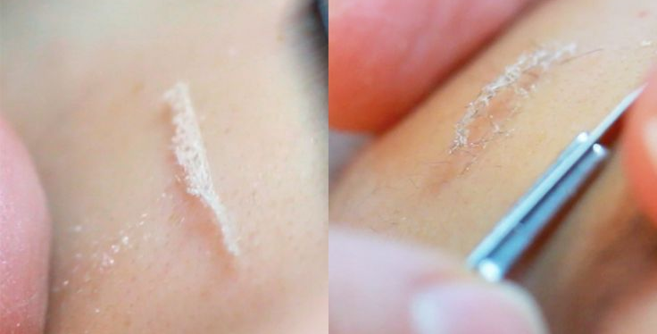
Image is
Dermaplaning
lifting old cells.

Health & Detox Treatments

Hopi Ear Candles

A relaxing treatment designed to help with a host of complaints involving a Hopi candle and a pressure point lymphatic face and neck massage.
Hopi Ear Candles can help with the following:
- Tinnitus, Sinusitis & Asthma - Compacted Ear Wax & Glue Ear
- Hay Fever - Headaches, Migraines & Pressure
- Stimulation of blood flow, energy flow & Lymphatic system

First Treatment £29 Following Treatment £39 Course of 3 £90 Course of 6 £170

Callous Peel

Hard or cracked skin on your feet? Then this is for you – A lovely and relaxing treatment to leave your feet in great shape.

Heel or Ball and Leg Massage - £26.50 Heel and Ball and Leg Massage - £32.50

Food Intolerance and Medical Testing
Type of Test | Cost
Simple Food Intolerance  – in clinic same day results  (48 foods tested with ‘yes’ or ‘no’ feedback) | 1 Person - £179 | 2 People - £299
In depth Food Intolerance (Detailed lab report on varying levels of intolerance) | £318
Coeliac | £179
Candida | £179
Vitamin D | £119
Thyroid | £191
Body TLC believes that everyone has the right to feel in control of their own health, and now it couldn’t be simpler! Testing is quick, safe, and affordable, simply book your appointment and receive your results immediately OR at a consultation 10 days later OR via Royal Mail!
Aqua Detox
The Aqua Detox is a gentle and relaxing treatment which will help re-balance, re-energise, and detoxify your body and brain. This is a 30 – 45-minute treatment. Drawing impurities out through the soles of your feet in a special ionic bath.

First Treatment £18 Following Treatments £24 Course of 10 £192
Photo depicts the treatment after 5 minutes and after 30 minutes
The water changes are evidence of the toxins being secreted.
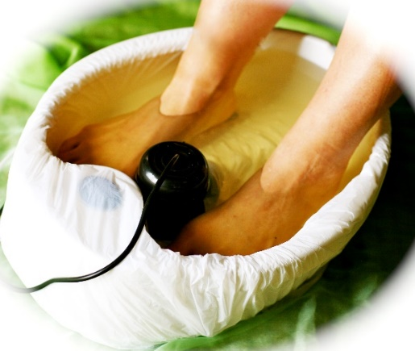
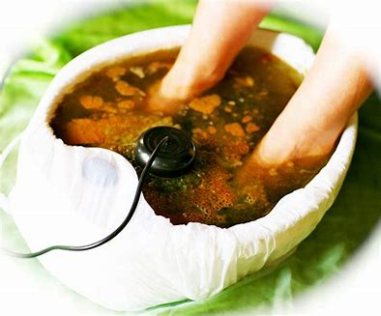

B12 Injections
Vitamin B12 shots are the most common way to prevent or treat a deficiency
B12 is necessary for memory, energy, and a healthy life. Often, we are depleted of this vital vitamin, not absorbing enough of it in our food. We can offer a simple 3 monthly injectable to boost your supplies, giving your energy and concentration a boost also. Learn more on how this can help you on our website or at a free consultation.
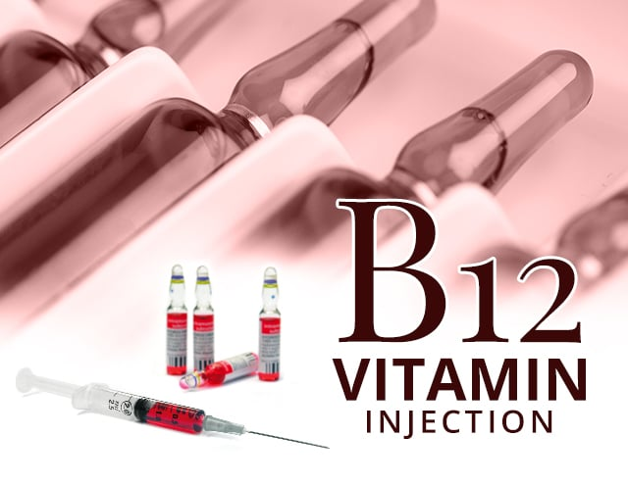
Per Treatment £28

Life Coaching

Would you like to gain the most from your goals and ideas?
Whether you’re stuck or looking for something new, Body TLC can help you change your life. We have teamed up with Paul, a professional Life Coach and Mentor.

Offering free tools, inspiring resources, thought provoking blogs and ideas.

We can help provide you with:
- Life Coaching and Mentoring.
- Instigating personal growth and development.
- Looking at your limiting beliefs.
- 1-2-1 self-development sessions.
- Improving confidence and self-belief.

How Life Coaching and Mentoring Can Help You

Find the answers to your life questions, get clarity, and grow into the person you would like to be.
Help address your problems and create a way forward for you.
Feel better about yourself and grow mentally, physically and spiritually.
We can help you with Self-Confidence, Anxiety, Procrastination and Self Development

Appointments are 100% confidential and all information is stored securely in line with strict GDPR guidelines.

First Assessment is 100% Free!

Book Online:
Evening appointments available outside of our clinics usual opening hours.
Using our telehealth appointments, you can speak via encrypted secure, video call with Paul Stevenson, he is non-judgemental & easy to talk to.
100% money back guarantee.

SESSION | COST
Initial 20 minute Assessment | Free of charge
60 minute Appointment (most popular) | £65
90 minute Deep Dive Appointment | £90
30 minute Follow up Accountability Call | £40
Package Treatments

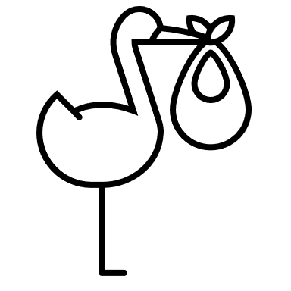
Mum to Be Package
During pregnancy, we can feel tired, achy, and generally sore. Why not treat yourself to a little indulgence and enjoy some pampering?
Included in this package:
- Luxury Gel Pedicure.
- Express Facial.
- Neck & Shoulder or Lumber Back Massage with our Aqua Mat*.
(*Aqua mats allow the entire massage to be completed with the mum to be laying on her back, protecting the precious cargo up front)
Only £78 (total 300 minutes)

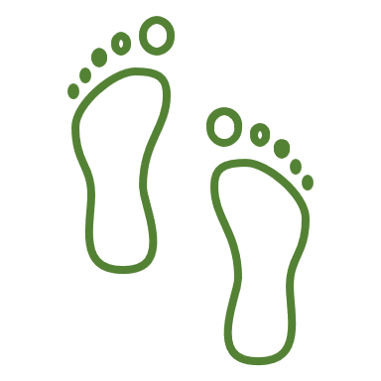
Feet Retreat
A luxurious treatment to indulge the feet and treat them to some deep nourishment and well-deserved pampering! This treatment includes an Aqua Detox to draw out toxins, followed by your choice of Luxury Foot Mask with Heated Booties and finished off with a Pedicure and Polish.
Only £40
Student Package
Student life can be hectic and stressful. Let us give you a little treat with our Student Package here at Body TLC.
Included in this package: (60 minutes). (Student ID required at time of treatment)
- 20 Minute Back Massage.
- Express Facial.
- Lash Tint.
- Brow Tint.
Only £30
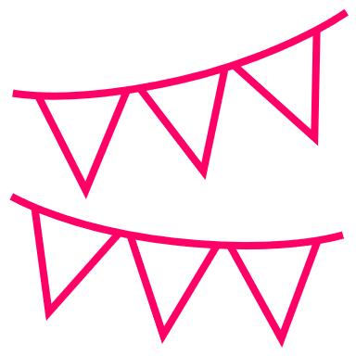
Bridal Party Packages
We’d love to help make your special day the best it can be, so we have come up with a deal to help make that happen.

Book any 3 treatments and get 10% off.
Book any 5 treatments and get 15% off.
Book any 8 treatments and get 20% off.
Book 3 months in advance = gain a further 10% Discount!
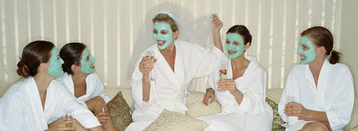

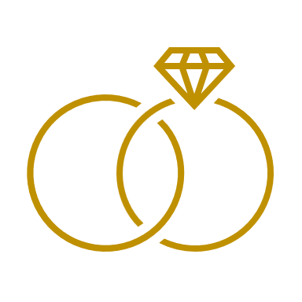
The ‘I DO’ Deal
We know the stress of preparing to say I do, so if you are the bride or groom, we want to help you prepare. We have packaged our most commonly requested treatments into the following mega deals.
Deal | What’s Included | Cost
The Promise | Brow Wax & Tint, Lash Lift and Tint, Full Legs & Bikini Wax, a Full Body Inch Loss Body Wrap & Dermaplaning Facial. RRP £229 | £170  SAVE £59
I Do… | As above for one, plus Laser Teeth Whitening for 2 people (your partner or member of the wedding party). RRP £427 | £327  SAVE £100
Un Veiling | A Male Facial with extraction of blackheads,  Brow Tidy, No Varnish Manicure for neat, prepared hands, for those close-up ring shots.  Ear and Nose Waxing & Laser Teeth Whitening (for one). RRP £183 | £150  SAVE £33

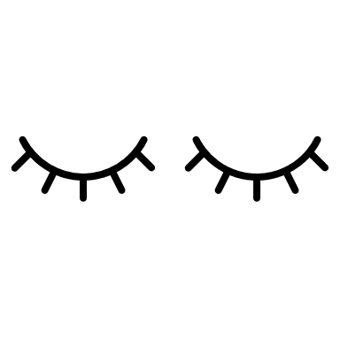
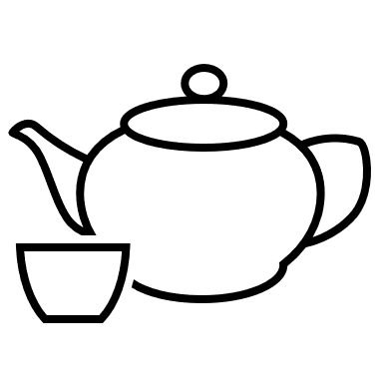
Couples & Friends Pamper Day for Two
Please note; we are not a typical day spa however, we can still offer you a lovely day of relaxation. So much so that Body TLC won ‘Best Day Spa’ in 2019 and
‘Best Luxury Day Spa~Lincolnshire’ in 2020

Our pamper day package includes:
Welcome greeting & your choice of complimentary coffee/tea from our selection.
Couples/Friends Full Body Hot Oil Wrap, gentle exfoliation, followed by an envelopment of warm oils and heated blankets.
Followed by a 55-minute Full Body Massage - choice of Swedish or Hot Stones*.
Slip into our fluffy robes and slippers to enjoy a coffee and cake, or complimentary glass of prosecco*.
Once your taste buds have been tantalised, lay back and enjoy a luxury facial - starting with Woods Lamp consultation so our trained therapists can tailor the products perfect for you.
Finally enjoy a File and Polish and enjoy and a blissful Head Massage (gentlemen can have a mini mani instead of file and polish).
​Our package gives you approximately 4 hours of TLC - the perfect way to catch up with a friend or loved one, that long overdue catch-up and our treatment selection will leave you feeling wonderfully refreshed.
The value of this package per person would be £193 per person - two people can enjoy this pamper day for a huge Saving of £176.

Package Price for 2 people ONLY £210

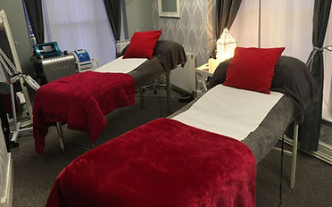
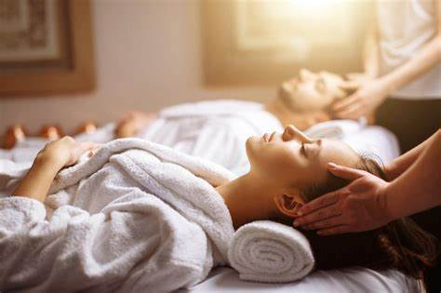
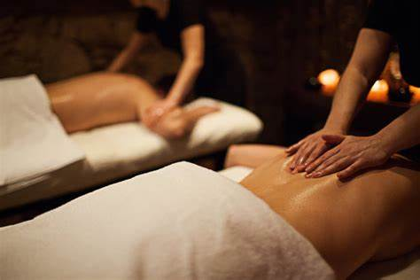
*This package can be upgraded to include Hot Stones and a complimentary glass of Prosecco for £12 pp

Please phone the clinic to book (01522 394618) - due to the length of time and the need for two therapists to be available, this treatment cannot be booked online.
Membership ‘Loyalty-LC’ Scheme
Love Massage and/ or Beauty? Then why not join our loyalty Scheme? This is a great way to save over the year. Pay monthly and spread the cost.
Select the scheme to suit your needs.
Sign up online at www.BodyTLC.co.uk/memberships-at-body-tlc
Massage ‘Loyalty-LC’ Scheme
Scheme | What’s included | Cost
TLC Package | 6 x 55-minute Swedish Massages per year – Save £48 per year! | £18  Per Month
Retreat Package | 9 x 55-minute Swedish Massages per year. Upgrade 2 of the 9 to Hot Stones Massage FREE – Save £62 per year! | £28  Per Month
Escape Package | 12 x 55-minute Swedish Massages per year. Upgrade 2 of the 12 to Hot Stones Massage & Express Facials FREE – Save £105 per yr | £35  Per Month
Beauty ‘Loyalty-LC’ Scheme
Scheme | What’s included | Cost
Allure Package | 4 x Lash & Brow Tint & Shapes. 2 x Lash Lift & Tints. 4 x Gel File & Polishes Save £60 pyr | £19  Per Month
Elegance Package | 6 x Lash & Brow Tint & Shapes.  4 x Lash Lifts.  6 x Gel File & Polishes – Save £86 per year! | £32  Per Month
Glamour Package | 6 x Lash & Brow Tint & Shapes.  6 x Lash Lifts.  6 x Gel File & Polish – Save £114 per year! | £36  Per Month

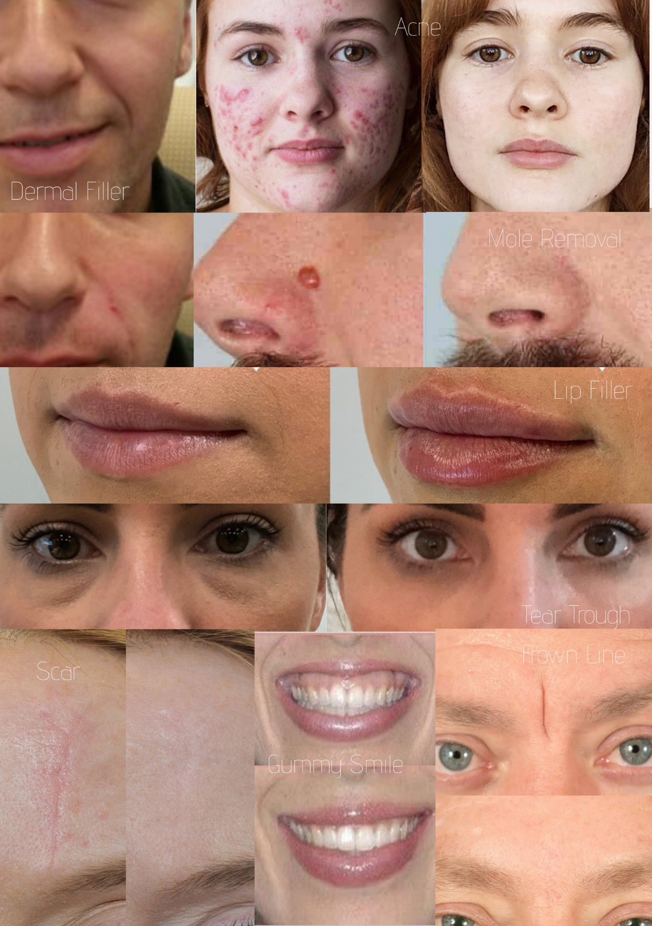

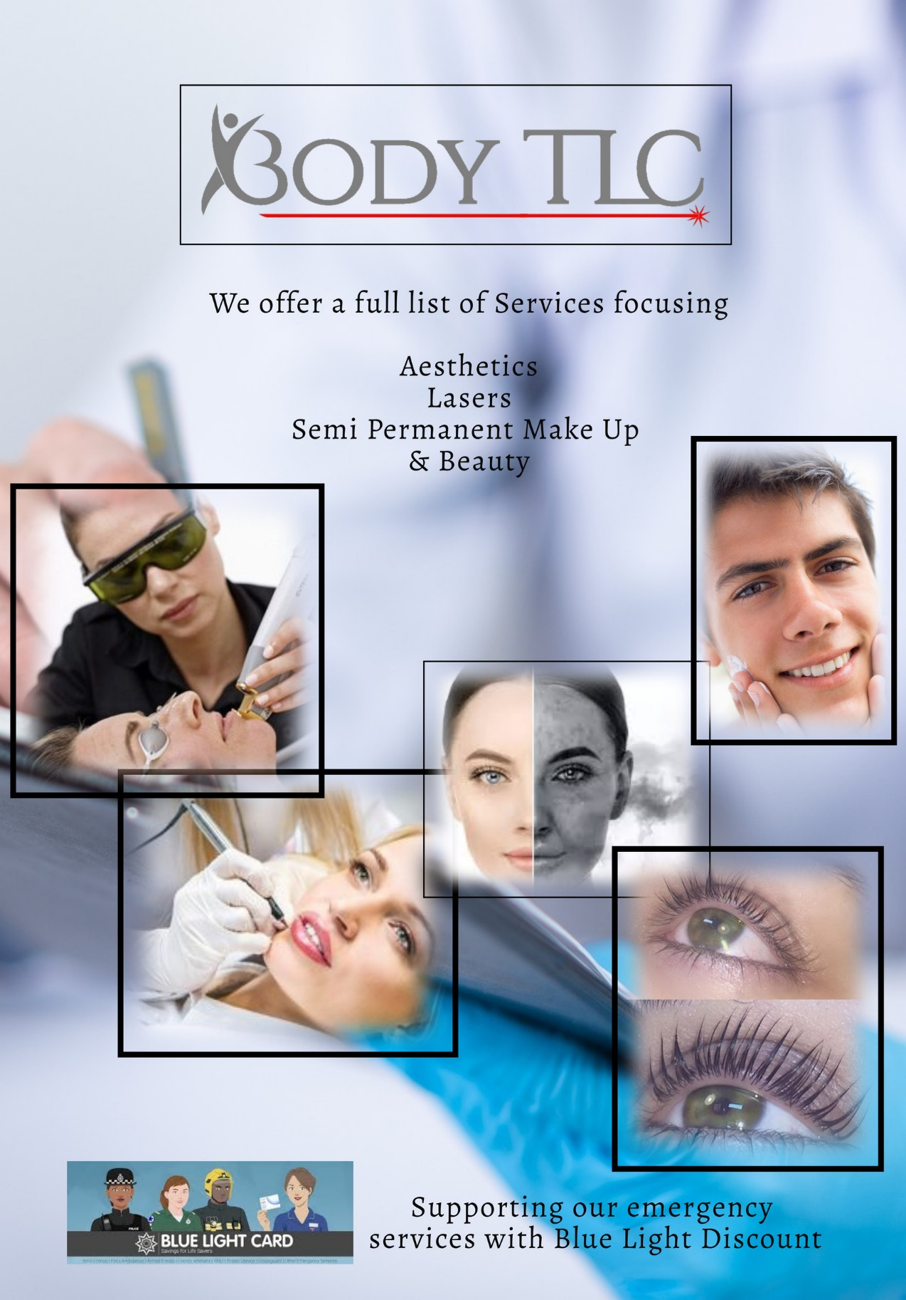

on

