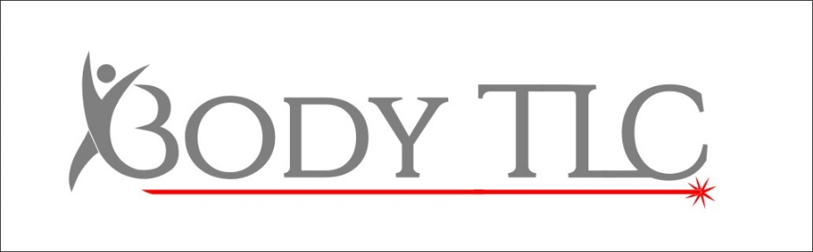

Wonderlift AFTERCARE
- For the first 24 hours after your treatment you may feel some tenderness and mild discomfort
- Everyday between sessions you must massage the breast tissue to help reinforce the stimulation
- Try to sleep on your back to avoid added pressure to one breast more so than the other
- Do not wear restricted clothing, over tight bras etc as this can limit growth,
- Wear the same bra to each fitting so that photos can be consistent, even if you bring another to change into for comfort before/after.
Very occasionally you may get a blister, if this occurs keep the area clean and dry, do not rub aggressively when towel drying and try and ventilate as much as possible to quicken up the healing process. Quicker healing plasters from Wilko/Boots may help speed up any possible blisters.
If you’re in any doubt, or have any concerns at all please call us on 01522 394618

