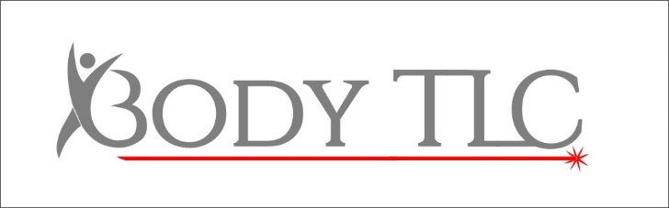
Who we are
- Company Name: Body TLC.
- Address: 405 High Street, Lincoln, LN5 7TE.
- Contact Phone Number: 01522 394618.
- Email: bodytlclincoln@gmail.com or info@bodytlc.co.uk
- Website: www.bodytlc.co.uk
- We are a Laser Clinic specialising in Laser treatments such as Laser Hair Removal, also offering a Beauty aspect with treatments such as waxing and tinting.
What information we hold
- Name.
- Address.
- Email.
- Phone number
- Date of birth.
- Parental details (as well as your own) if under 18.
- Medical history.
- Skin type.
- Consent form for treatments.
- Waiver.
- Date you visit the clinic.
- What treatment/s you have.
- Notes on the treatment, with your signature to confirm.
- Photographs if taken.
- Cost you paid.
- Who your treatment was with.
- If you have given consent for photographic usage.
- Any details of issues raised, and action taken.
- Any emails sent bringing up complaints.
Where we get our information
- Directly from customers when they phone, email, or come into clinic and fill paperwork in.
- Directly from potential customers at events or social media.
What we do with information we hold
- Written up.
- Written copies of notes are collated per client and filed alphabetically in a storage unit under CCTV and kept in a locked building overnight still under CCTV.
- Copied to digital format and kept on an external hard drive which is locked away overnight, kept within sight all day and under CCTV.
- Digital copies are backed up onto a second external hard drive which is also locked away overnight, kept within sight all day and under CCTV.
- Emails are collated on the above mentioned external hard drive, and added to our booking system (Setmore), where necessary to our email providers (bodytlclincoln@gmail.com and info@bodytlc.co.uk), and also to a external email system to use to send monthly offers (mail chimp).
- Notes are taken following treatment, which a client signs, for the purpose of continuity, understanding over time if a client returns following a break, to monitor a clients medical concerns which may cause contraindications to treatment, for a different therapist to understand previous treatments and in the case of litigation being brought against the Clinic.
How long we keep information
- Records are kept for 7 years.
- Where a complaint has been made, records are kept indefinitely.
- Once the 7 year period has passed, records are shredded, except in the above instance.
Why it is legal for us to hold information
- The lawful basis for us to keep data is to protect both parties should one party be unhappy with treatment and the result being taken to court.
- Another lawful basis for us to keep data is to avoid complications following treatment in regards to medical issues.
How to complain about how we handle data.
- Should I feel the need to complain about how my data is handled at Body TLC I can contact the Information’s Commissions Office via the following link https://ico.org.uk/make-a-complaint/ or by calling their helpline on 0303 123 1113.

